**MANUAL FOR;**

DESIGN AND IMPLEMENTATION OF A WEB PLATFORM FOR ENHANCING BLOOD DONATION AND SUPPLY CHAIN MANAGEMENT IN GHANA.

**1.0 INTRODUCTION**

Welcome to our website! This manual is designed to help you navigate and utilize our platform effectively for enhancing blood donation and supply chain management in Ghana. Our goal is to streamline the process of blood donation, increase awareness, and improve the overall efficiency of blood supply management in the country.

**1.1 ACCESSING THE WEBSITE**

**Navigating to the Website**

To access the web platform:

1. Open a Web Browser: Use any modern web browser such as Chrome, Firefox, Safari, or Edge.

2. Enter the URL: Type the official website address into the address bar. For example:

www.blooddonationgh.com. Press Enter to load the site.

3. Homepage Overview: Once the page loads, you will see the homepage featuring:

* Navigation menu with options such as Register as a Donor, Book an appointment and Blood Store.
* Display of various banners.
* Statistics sections.
* About Us section.
* Our service section.

**1.2 HOW TO USE THE WEBSITE**

**1.2.1 REGISTERING AS A DONOR**

To sign up as a blood donor through our platform:

1. Navigate to 'Register as a Donor'. Click on the "Register as Donor" option in the navigation menu.

2. Fill Out the Registration Form. Provide the required information, such as; your name, phone number and address.

The image below shows the registration form.

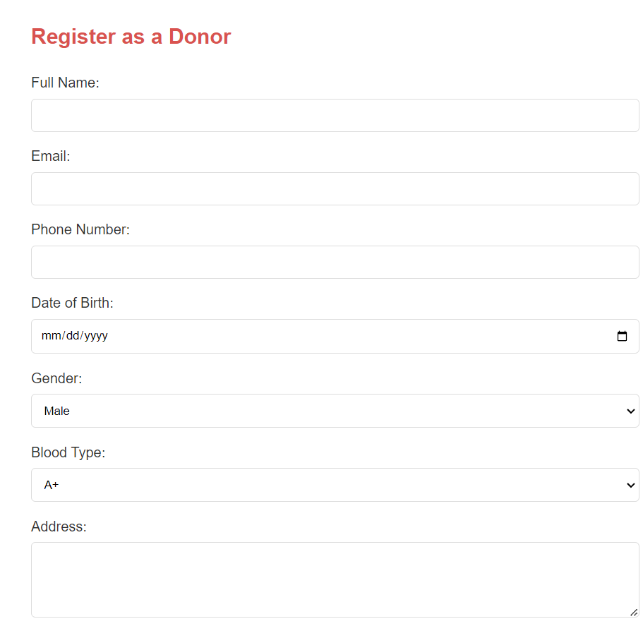

3. Submit Your Information: After filling in all necessary fields. Click the “Register” button. You will receive a confirmation email with further instructions.

4. Verification: Your information will be reviewed, and you will be notified about your registration status.

**1.2.2 BOOKING AN APPOINTMENT**

To book an appointment:

1. Go to 'Book an Appointment' on the navigation menu. Select the "Book an Appointment" option from the navigation menu.

2. Fill out the form below to schedule an appointment at your nearest donor centre.

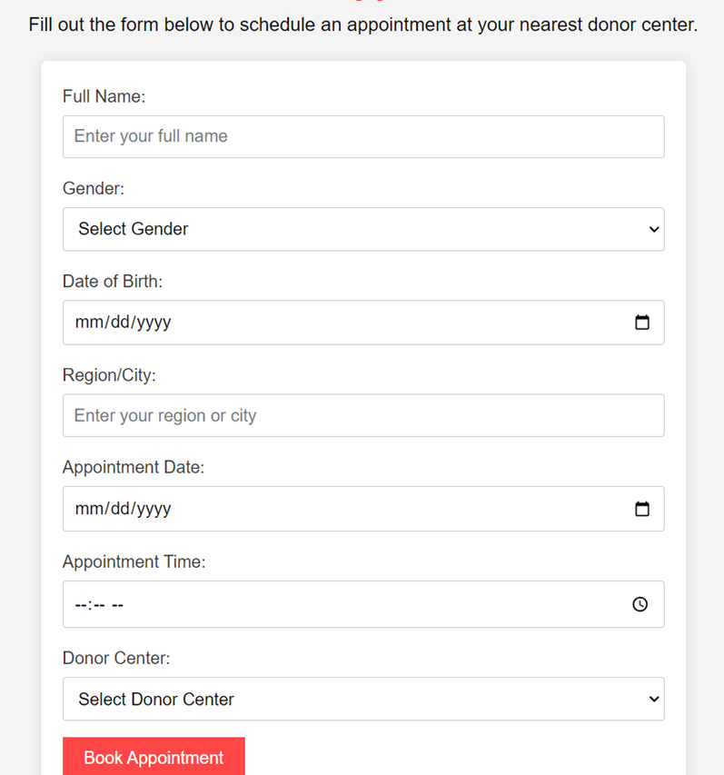

3. After filling out the form, click on the ‘Book appointment’ button to submit your information.

**1.2.3 BLOOD REQUEST**

To request for blood:

1. Select ‘Request Blood’ on the navigation menu.

2. Fill the ‘Request Form’ according to the details provided in the image below.

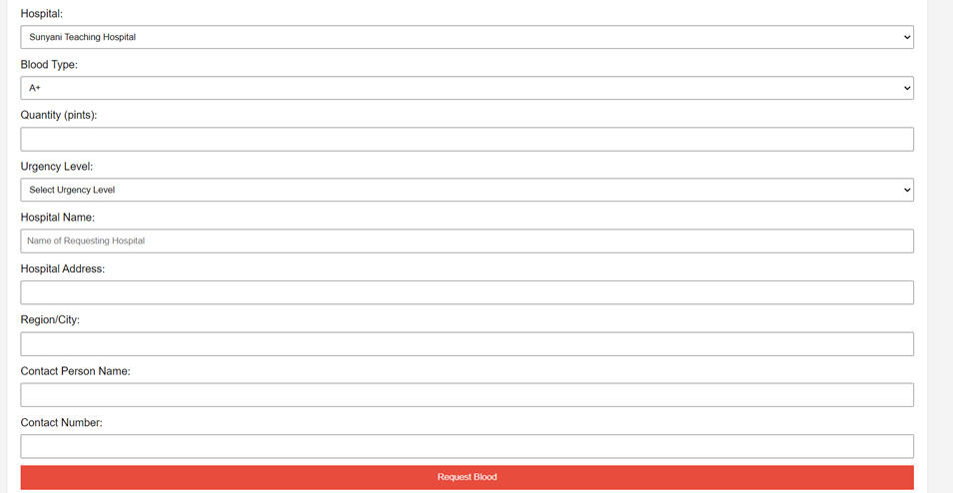

3. Click the ‘Request Blood’ button after the filling the form. Response from the selected hospital will be given.

**1.2.4 ACCESSING EDUCATIONAL RESOURCES**

To educate yourself about blood donation**:**

1. Click on 'Educational Resources: This section includes Educational Resources on Blood Donation, Important Facts About Blood Donation and Blood Donation Statistics as shown below.

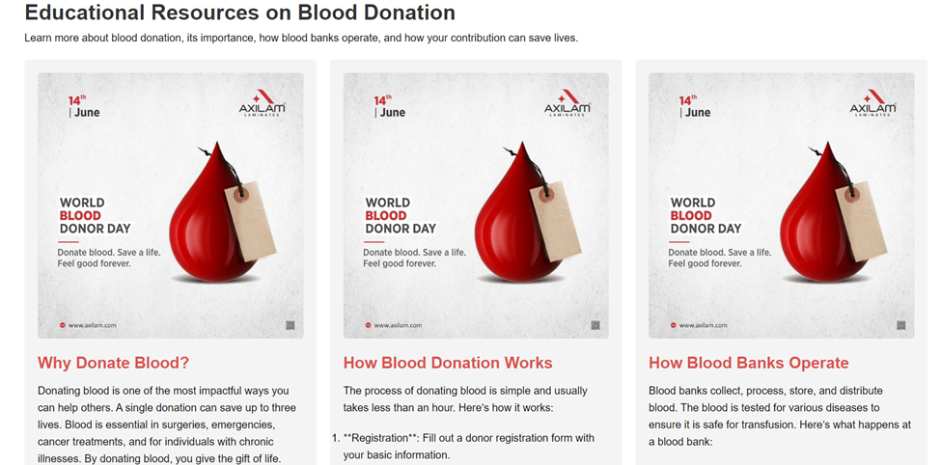

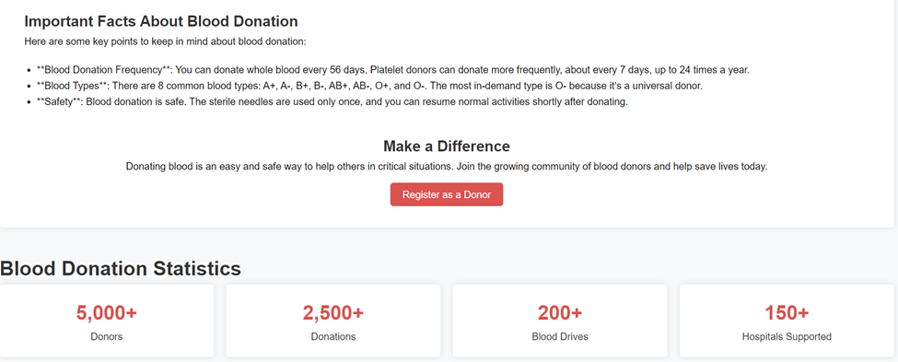

2. Browse Topics: Explore various topics related to blood donation, including:

* Why donate blood?
* How Blood Donation Works.
* How Blood Banks Operate.

**1.2.5 BLOOD STORE**

To purchase blood:

1. Click on ‘Blood Store’ on the navigation menu.

2. Select your preferred blood type and click on the ‘Add to Cart’ button as shown below.

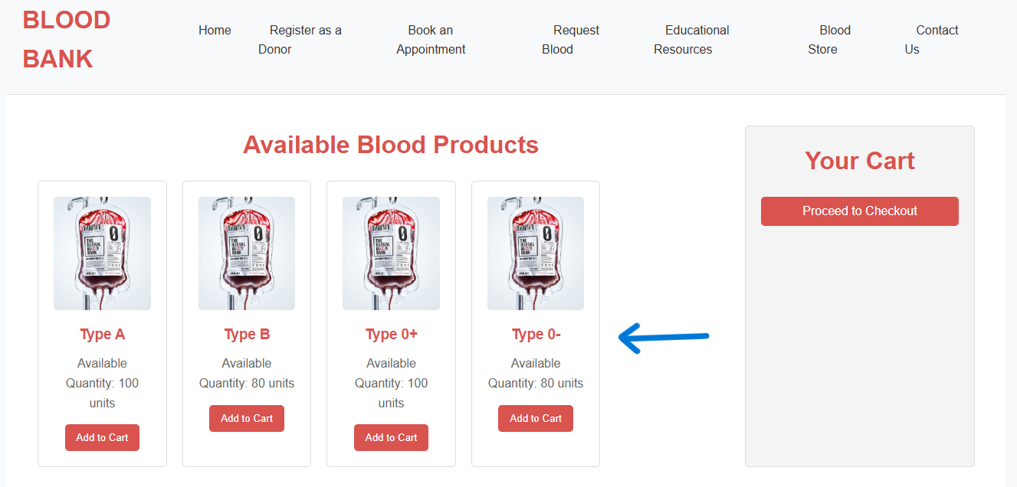

3. A pop-up menu will display. Enter the required amount you want based on the quantity of the blood type you are requesting. The image below shows the pop-up menu.

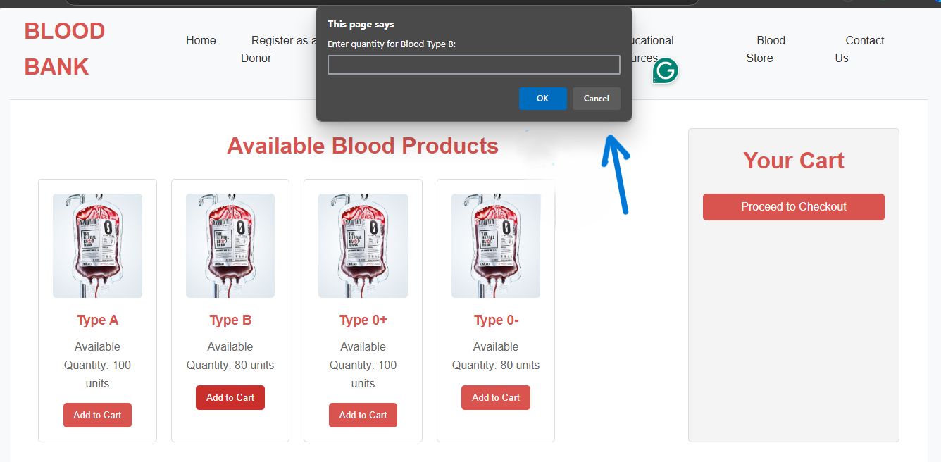

4. After typing the amount needed. Click on the ‘Ok’ button as shown below.

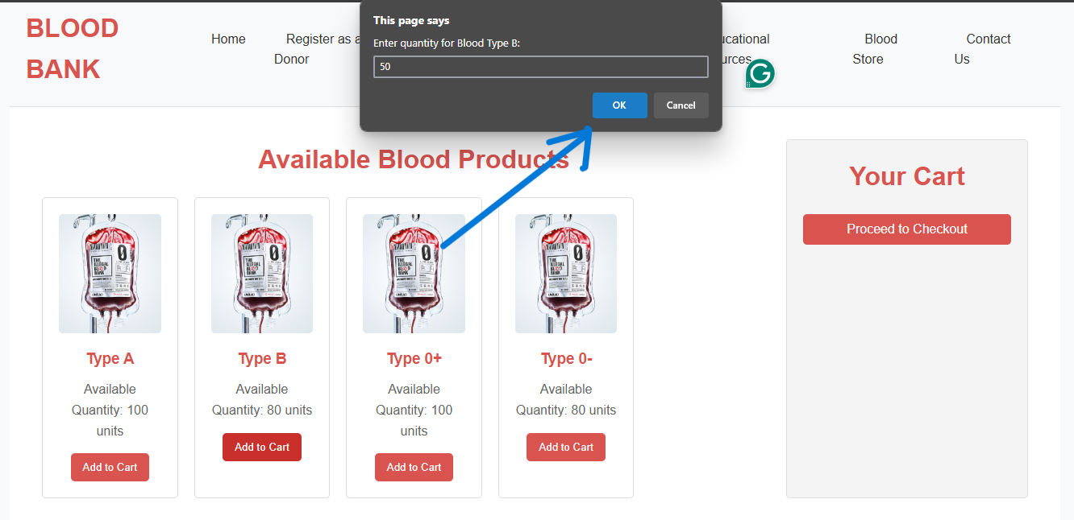

5. After clicking the ‘Ok’ button, your preferred blood type and the amount you typed will be added to your cart or seen in the cart section as shown in the image below.

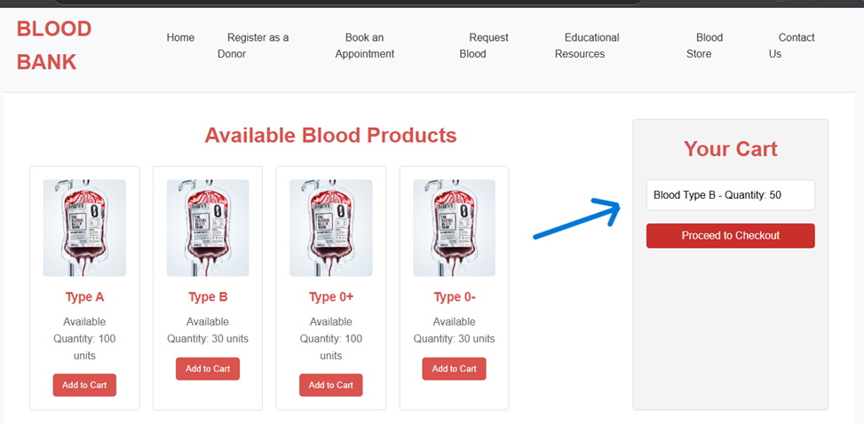

6. Click the ‘Proceed to Checkout’ button as shown in the image above to make the required payment.

**1.2.6 CONTACTING US**

If you have questions or need assistance:

1. Navigate to ‘Contact Us’: Click on this option in the navigation menu.

2. Fill Out the Contact Form: Provide your name, email, subject, and message.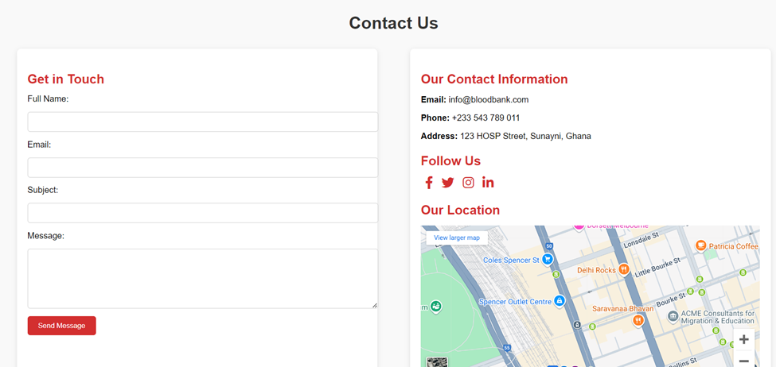3. Submit Your Inquiry: Click "Send Message." Our team will respond to your inquiry as soon as possible.